**Лабораторна робота № 30 «Застосування валідації у реєстраційній формі користувача»**

У роботі потрібно створити додаток для реєстрації користувача, використовуючи Spring Boot + Spring Validation + Thymeleaf. Теми згадувані в цій статті включають:

1. Створити форму для реєстрації на Spring.
2. Скористайтеся Spring Validator для підтвердження (валідації) інформації, яку ввів користувач.
3. Оголосити принцип роботи Spring Validator.

Переглянути додатки:



2- Створити проект Spring Boot

В Eclipse створити проект Spring Boot .

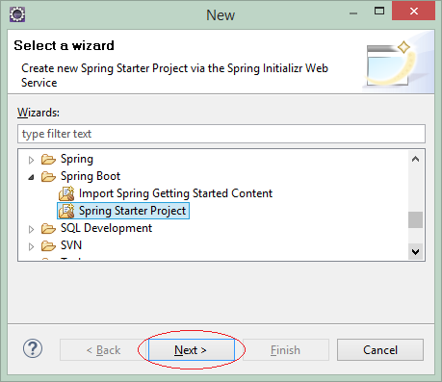

Ввести:

* Назва: SbRegistrationFormValidationThymeleaf
* Група: org.o7planning
* Опис: Spring Boot + Form Validation + Thymeleaf
* Пакет: org.o7planning.sbformvalidation

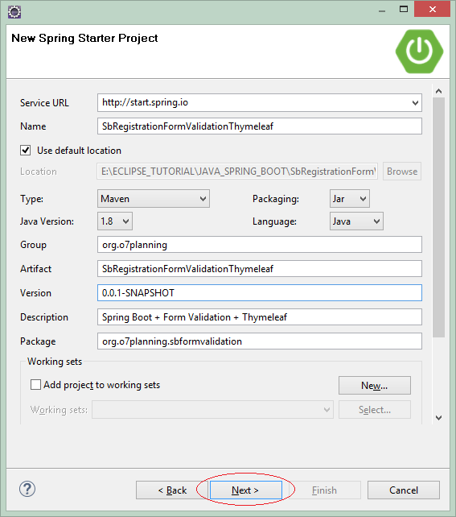

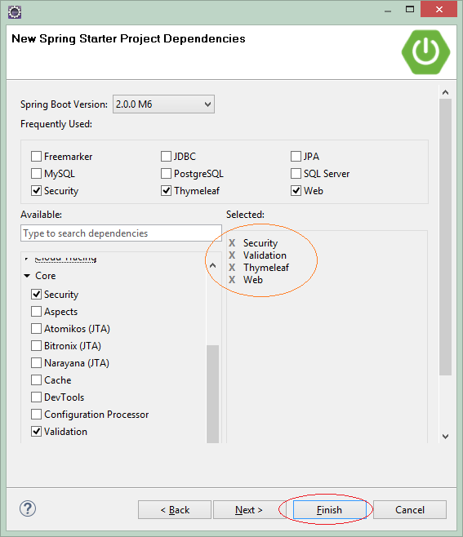

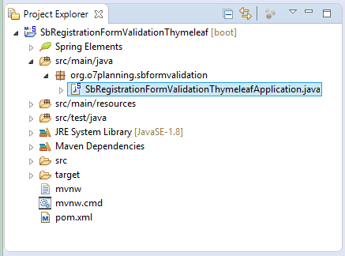

SbRegistrationFormValidationThymeleafApplication.java

**package** org.o7planning.sbformvalidation;

**import** org.springframework.boot.SpringApplication;

**import** org.springframework.boot.autoconfigure.SpringBootApplication;

@SpringBootApplication

**public** **class** **SbRegistrationFormValidationThymeleafApplication** {

**public** **static** **void** **main**(String[] args) {

SpringApplication.run(SbRegistrationFormValidationThymeleafApplication.class, args);

}

}

3- Конфігурація pom.xml

У цьому прикладі ми використовуємо бібліотеку Commons Validation , щоб перевірити точність електронної пошти, яка є користувачем. тому потрібно опублікувати дану бібліотеку в pom.xml .

** Commons Validation **

<**dependencies**>

.....

<!-- https://mvnrepository.com/artifact/commons-validator/commons-validator -->

<**dependency**>

<**groupId**>commons-validator</**groupId**>

<**artifactId**>commons-validator</**artifactId**>

<**version**>1.6</**version**>

</**dependency**>

.....

</**dependencies**>

Повний вміст файлу pom.xml :

pom.xml

<?xml version="1.0" encoding="UTF-8"?>

<**project** xmlns="http://maven.apache.org/POM/4.0.0"

xmlns:xsi="http://www.w3.org/2001/XMLSchema-instance"

xsi:schemaLocation="http://maven.apache.org/POM/4.0.0

http://maven.apache.org/xsd/maven-4.0.0.xsd">

<**modelVersion**>4.0.0</**modelVersion**>

<**groupId**>org.o7planning</**groupId**>

<**artifactId**>SbRegistrationFormValidationThymeleaf</**artifactId**>

<**version**>0.0.1-SNAPSHOT</**version**>

<**packaging**>jar</**packaging**>

<**name**>SbRegistrationFormValidationThymeleaf</**name**>

<**description**>Spring Boot + Form Validation + Thymeleaf</**description**>

<**parent**>

<**groupId**>org.springframework.boot</**groupId**>

<**artifactId**>spring-boot-starter-parent</**artifactId**>

<**version**>2.0.0.RELEASE</**version**>

<**relativePath**/> <!-- lookup parent from repository -->

</**parent**>

<**properties**>

<**project.build.sourceEncoding**>UTF-8</**project.build.sourceEncoding**>

<**project.reporting.outputEncoding**>UTF-8</**project.reporting.outputEncoding**>

<**java.version**>1.8</**java.version**>

</**properties**>

<**dependencies**>

<**dependency**>

<**groupId**>org.springframework.boot</**groupId**>

<**artifactId**>spring-boot-starter-security</**artifactId**>

</**dependency**>

<**dependency**>

<**groupId**>org.springframework.boot</**groupId**>

<**artifactId**>spring-boot-starter-thymeleaf</**artifactId**>

</**dependency**>

<**dependency**>

<**groupId**>org.springframework.boot</**groupId**>

<**artifactId**>spring-boot-starter-validation</**artifactId**>

</**dependency**>

<**dependency**>

<**groupId**>org.springframework.boot</**groupId**>

<**artifactId**>spring-boot-starter-web</**artifactId**>

</**dependency**>

<!-- https://mvnrepository.com/artifact/commons-validator/commons-validator -->

<**dependency**>

<**groupId**>commons-validator</**groupId**>

<**artifactId**>commons-validator</**artifactId**>

<**version**>1.6</**version**>

</**dependency**>

<**dependency**>

<**groupId**>org.springframework.boot</**groupId**>

<**artifactId**>spring-boot-starter-test</**artifactId**>

<**scope**>test</**scope**>

</**dependency**>

<**dependency**>

<**groupId**>org.springframework.security</**groupId**>

<**artifactId**>spring-security-test</**artifactId**>

<**scope**>test</**scope**>

</**dependency**>

</**dependencies**>

<**build**>

<**plugins**>

<**plugin**>

<**groupId**>org.springframework.boot</**groupId**>

<**artifactId**>spring-boot-maven-plugin</**artifactId**>

</**plugin**>

</**plugins**>

</**build**>

</**project**>

4- Безпека, MessageSource

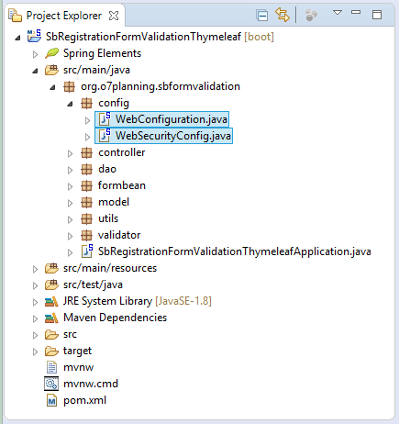

У цьому прикладі ми не зосереджені на питання безпеки додатків. Але нам знадобиться бібліотека Spring Security, щоб закодувати (закодувати) пароль користувача, перед тим як зберегти в базі даних. І вам потрібно об'явити Spring BEAN для кодування пароля.

WebSecurityConfig.java

**package** org.o7planning.sbformvalidation.config;

**import** org.springframework.context.annotation.Bean;

**import** org.springframework.context.annotation.Configuration;

**import** org.springframework.security.config.annotation.web.builders.HttpSecurity;

**import** org.springframework.security.config.annotation.web.configuration.EnableWebSecurity;

**import** org.springframework.security.config.annotation.web.configuration.WebSecurityConfigurerAdapter;

**import** org.springframework.security.crypto.bcrypt.BCryptPasswordEncoder;

**import** org.springframework.security.crypto.password.PasswordEncoder;

@Configuration

@EnableWebSecurity

**public** **class** **WebSecurityConfig** **extends** **WebSecurityConfigurerAdapter** {

@Bean

**public** PasswordEncoder **passwordEncoder**() {

BCryptPasswordEncoder bCryptPasswordEncoder = **new** **BCryptPasswordEncoder**();

**return** bCryptPasswordEncoder;

}

// In this example we do not use Security.

// Override this method with empty code

// to disable the default Spring Boot security.

@Override

**protected** **void** **configure**(HttpSecurity http) **throws** Exception {

// Empty code!

}

}

У цьому прикладі ми маємо файл validation.properties . Цей файл містить коди помилок (код помилки), які використовуються для повідомлення користувача, коли вони вводять неправильну інформацію.

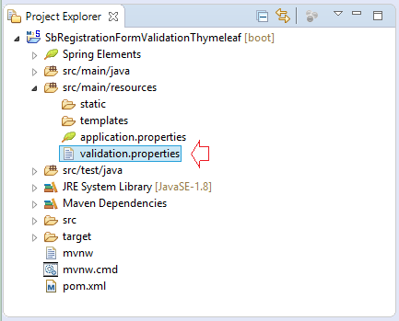

перевірка.властивості

NotEmpty.appUserForm.userName=User name is required

NotEmpty.appUserForm.firstName=First Name is required

NotEmpty.appUserForm.lastName=Last name is required

NotEmpty.appUserForm.email=Email is required

NotEmpty.appUserForm.password=Password is required

NotEmpty.appUserForm.confirmPassword=Confirm Password is required

NotEmpty.appUserForm.gender=Gender is required

NotEmpty.appUserForm.countryCode=Country is required

Pattern.appUserForm.email=Invalid email

Duplicate.appUserForm.email=Email has been used by another account

Duplicate.appUserForm.userName=Username is not available

Match.appUserForm.confirmPassword=Password does not match the confirm password

Вам потрібно об’явити MessageResource Spring Bean , щоб Spring автоматично завантажив (завантажив) вміст файлу validation.properties в пам’ять.

WebConfiguration.java

**package** org.o7planning.sbformvalidation.config;

**import** org.springframework.context.MessageSource;

**import** org.springframework.context.annotation.Bean;

**import** org.springframework.context.annotation.Configuration;

**import** org.springframework.context.support.ReloadableResourceBundleMessageSource;

**import** org.springframework.web.servlet.config.annotation.EnableWebMvc;

**import** org.springframework.web.servlet.config.annotation.WebMvcConfigurer;

@Configuration

@EnableWebMvc

**public** **class** **WebConfiguration** **implements** **WebMvcConfigurer** {

@Bean

**public** MessageSource **messageSource**() {

ReloadableResourceBundleMessageSource messageSource = **new** **ReloadableResourceBundleMessageSource**();

// Load file: validation.properties

messageSource.setBasename("classpath:validation");

messageSource.setDefaultEncoding("UTF-8");

**return** messageSource;

}

}

5- Модель, DAO

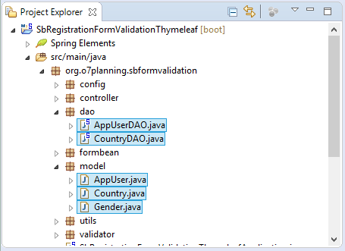

Клас AppUser представляє запис (запис) таблиці APP_USER . Він є користувачем (користувачем) успішно зареєстрованим у системі.

AppUser.java

**package** org.o7planning.sbformvalidation.model;

**public** **class** **AppUser** {

**private** Long userId;

**private** String userName;

**private** String firstName;

**private** String lastName;

**private** boolean enabled;

**private** String gender;

**private** String email;

**private** String encrytedPassword;

**private** String countryCode;

**public** **AppUser**() {

}

**public** **AppUser**(Long userId, String userName, String firstName, String lastName, //

boolean enabled, String gender, //

String email,String countryCode, String encrytedPassword) {

super();

this.userId = userId;

this.userName = userName;

this.firstName = firstName;

this.lastName = lastName;

this.enabled = enabled;

this.gender = gender;

this.email = email;

this.countryCode= countryCode;

this.encrytedPassword = encrytedPassword;

}

**public** Long **getUserId**() {

**return** userId;

}

**public** **void** **setUserId**(Long userId) {

this.userId = userId;

}

**public** String **getUserName**() {

**return** userName;

}

**public** **void** **setUserName**(String userName) {

this.userName = userName;

}

**public** String **getFirstName**() {

**return** firstName;

}

**public** **void** **setFirstName**(String firstName) {

this.firstName = firstName;

}

**public** String **getLastName**() {

**return** lastName;

}

**public** **void** **setLastName**(String lastName) {

this.lastName = lastName;

}

**public** boolean **isEnabled**() {

**return** enabled;

}

**public** **void** **setEnabled**(boolean enabled) {

this.enabled = enabled;

}

**public** String **getGender**() {

**return** gender;

}

**public** **void** **setGender**(String gender) {

this.gender = gender;

}

**public** String **getEmail**() {

**return** email;

}

**public** **void** **setEmail**(String email) {

this.email = email;

}

**public** String **getEncrytedPassword**() {

**return** encrytedPassword;

}

**public** **void** **setEncrytedPassword**(String encrytedPassword) {

this.encrytedPassword = encrytedPassword;

}

**public** String **getCountryCode**() {

**return** countryCode;

}

**public** **void** **setCountryCode**(String countryCode) {

this.countryCode = countryCode;

}

}

Country.java

**package** org.o7planning.sbformvalidation.model;

**public** **class** **Country** {

**private** String countryCode;

**private** String countryName;

**public** **Country**() {

}

**public** **Country**(String countryCode, String countryName) {

this.countryCode = countryCode;

this.countryName = countryName;

}

**public** String **getCountryCode**() {

**return** countryCode;

}

**public** **void** **setCountryCode**(String countryCode) {

this.countryCode = countryCode;

}

**public** String **getCountryName**() {

**return** countryName;

}

**public** **void** **setCountryName**(String countryName) {

this.countryName = countryName;

}

}

Стать.java

**package** org.o7planning.sbformvalidation.model;

**public** **class** **Gender** {

**public** **static** **final** String MALE = "M";

**public** **static** **final** String FEMALE = "F";

}

Класи DAO (Data Access Object) використовуються для маніпуляції з ресурсами даних, як наприклад query , insert , update , delete . Дані класи зазвичай анотуються (анотуються) за допомогою @Repository , щоб Spring керував ними як Spring BEAN.

AppUserDAO.java

**package** org.o7planning.sbformvalidation.dao;

**import** java.util.ArrayList;

**import** java.util.Collection;

**import** java.util.HashMap;

**import** java.util.List;

**import** java.util.Map;

**import** org.o7planning.sbformvalidation.formbean.AppUserForm;

**import** org.o7planning.sbformvalidation.model.AppUser;

**import** org.o7planning.sbformvalidation.model.Gender;

**import** org.springframework.beans.factory.annotation.Autowired;

**import** org.springframework.security.crypto.password.PasswordEncoder;

**import** org.springframework.stereotype.Repository;

@Repository

**public** **class** **AppUserDAO** {

// Config in WebSecurityConfig

@Autowired

**private** PasswordEncoder passwordEncoder;

**private** **static** **final** Map<Long, AppUser> USERS_MAP = **new** **HashMap**<>();

**static** {

initDATA();

}

**private** **static** **void** **initDATA**() {

String encrytedPassword = "";

AppUser tom = **new** **AppUser**(1L, "tom", "Tom", "Tom", //

true, Gender.MALE, "tom@waltdisney.com", encrytedPassword, "US");

AppUser jerry = **new** **AppUser**(2L, "jerry", "Jerry", "Jerry", //

true, Gender.MALE, "jerry@waltdisney.com", encrytedPassword, "US");

USERS_MAP.put(tom.getUserId(), tom);

USERS_MAP.put(jerry.getUserId(), jerry);

}

**public** Long **getMaxUserId**() {

long max = 0;

**for** (Long id : USERS_MAP.keySet()) {

**if** (id > max) {

max = id;

}

}

**return** max;

}

//

**public** AppUser **findAppUserByUserName**(String userName) {

Collection<AppUser> appUsers = USERS_MAP.values();

**for** (AppUser u : appUsers) {

**if** (u.getUserName().equals(userName)) {

**return** u;

}

}

**return** null;

}

**public** AppUser **findAppUserByEmail**(String email) {

Collection<AppUser> appUsers = USERS_MAP.values();

**for** (AppUser u : appUsers) {

**if** (u.getEmail().equals(email)) {

**return** u;

}

}

**return** null;

}

**public** List<AppUser> **getAppUsers**() {

List<AppUser> list = **new** **ArrayList**<>();

list.addAll(USERS_MAP.values());

**return** list;

}

**public** AppUser **createAppUser**(AppUserForm form) {

Long userId = this.getMaxUserId() + 1;

String encrytedPassword = this.passwordEncoder.encode(form.getPassword());

AppUser user = **new** **AppUser**(userId, form.getUserName(), //

form.getFirstName(), form.getLastName(), false, //

form.getGender(), form.getEmail(), form.getCountryCode(), //

encrytedPassword);

USERS_MAP.put(userId, user);

**return** user;

}

}

CountryDAO.java

**package** org.o7planning.sbformvalidation.dao;

**import** java.util.ArrayList;

**import** java.util.HashMap;

**import** java.util.List;

**import** java.util.Map;

**import** org.o7planning.sbformvalidation.model.Country;

**import** org.springframework.stereotype.Repository;

@Repository

**public** **class** **CountryDAO** {

**private** **static** **final** Map<String, Country> COUNTRIES_MAP = **new** **HashMap**<>();

**static** {

initDATA();

}

**private** **static** **void** **initDATA**() {

Country vn = **new** **Country**("VN", "Vietnam");

Country en = **new** **Country**("EN", "England");

Country fr = **new** **Country**("FR", "France");

Country us = **new** **Country**("US", "US");

Country ru = **new** **Country**("RU", "Russia");

COUNTRIES_MAP.put(vn.getCountryCode(), vn);

COUNTRIES_MAP.put(en.getCountryCode(), en);

COUNTRIES_MAP.put(fr.getCountryCode(), fr);

COUNTRIES_MAP.put(us.getCountryCode(), us);

COUNTRIES_MAP.put(ru.getCountryCode(), ru);

}

**public** Country **findCountryByCode**(String countryCode) {

**return** COUNTRIES_MAP.get(countryCode);

}

**public** List<Country> **getCountries**() {

List<Country> list = **new** **ArrayList**<>();

list.addAll(COUNTRIES_MAP.values());

**return** list;

}

}

6- Компонент форми, засіб перевірки

Клас AppUserForm представляє дані, які користувач повинен ввести в реєстрацію форми.

AppUserForm.java

**package** org.o7planning.sbformvalidation.formbean;

**public** **class** **AppUserForm** {

**private** Long userId;

**private** String userName;

**private** String firstName;

**private** String lastName;

**private** boolean enabled;

**private** String gender;

**private** String email;

**private** String password;

**private** String confirmPassword;

**private** String countryCode;

**public** **AppUserForm**() {

}

**public** **AppUserForm**(Long userId, String userName, //

String firstName, String lastName, boolean enabled, //

String gender, String email, String countryCode, //

String password, String confirmPassword) {

this.userId = userId;

this.userName = userName;

this.firstName = firstName;

this.lastName = lastName;

this.enabled = enabled;

this.gender = gender;

this.email = email;

this.countryCode = countryCode;

this.password = password;

this.confirmPassword = confirmPassword;

}

**public** Long **getUserId**() {

**return** userId;

}

**public** **void** **setUserId**(Long userId) {

this.userId = userId;

}

**public** String **getUserName**() {

**return** userName;

}

**public** **void** **setUserName**(String userName) {

this.userName = userName;

}

**public** String **getFirstName**() {

**return** firstName;

}

**public** **void** **setFirstName**(String firstName) {

this.firstName = firstName;

}

**public** String **getLastName**() {

**return** lastName;

}

**public** **void** **setLastName**(String lastName) {

this.lastName = lastName;

}

**public** boolean **isEnabled**() {

**return** enabled;

}

**public** **void** **setEnabled**(boolean enabled) {

this.enabled = enabled;

}

**public** String **getGender**() {

**return** gender;

}

**public** **void** **setGender**(String gender) {

this.gender = gender;

}

**public** String **getEmail**() {

**return** email;

}

**public** **void** **setEmail**(String email) {

this.email = email;

}

**public** String **getCountryCode**() {

**return** countryCode;

}

**public** **void** **setCountryCode**(String countryCode) {

this.countryCode = countryCode;

}

**public** String **getPassword**() {

**return** password;

}

**public** **void** **setPassword**(String password) {

this.password = password;

}

**public** String **getConfirmPassword**() {

**return** confirmPassword;

}

**public** **void** **setConfirmPassword**(String confirmPassword) {

this.confirmPassword = confirmPassword;

}

}

Клас AppUserValidator використовується для валідації (перевірки) інформації, яка є користувачем у формі. Таким чином AppUserValidator перевіряє (підтверджує) значення поля (поля) об’єктів AppUserForm.

AppUserValidator.java

**package** org.o7planning.sbformvalidation.validator;

**import** org.apache.commons.validator.routines.EmailValidator;

**import** org.o7planning.sbformvalidation.dao.AppUserDAO;

**import** org.o7planning.sbformvalidation.formbean.AppUserForm;

**import** org.o7planning.sbformvalidation.model.AppUser;

**import** org.springframework.beans.factory.annotation.Autowired;

**import** org.springframework.stereotype.Component;

**import** org.springframework.validation.Errors;

**import** org.springframework.validation.ValidationUtils;

**import** org.springframework.validation.Validator;

@Component

**public** **class** **AppUserValidator** **implements** **Validator** {

// common-validator library.

**private** EmailValidator emailValidator = EmailValidator.getInstance();

@Autowired

**private** AppUserDAO appUserDAO;

// The classes are supported by this validator.

@Override

**public** boolean **supports**(Class<?> clazz) {

return clazz == AppUserForm.class;

}

@Override

**public** **void** **validate**(Object target, Errors errors) {

AppUserForm appUserForm = (AppUserForm) target;

// Check the fields of AppUserForm.

ValidationUtils.rejectIfEmptyOrWhitespace(errors, "userName", "NotEmpty.appUserForm.userName");

ValidationUtils.rejectIfEmptyOrWhitespace(errors, "firstName", "NotEmpty.appUserForm.firstName");

ValidationUtils.rejectIfEmptyOrWhitespace(errors, "lastName", "NotEmpty.appUserForm.lastName");

ValidationUtils.rejectIfEmptyOrWhitespace(errors, "email", "NotEmpty.appUserForm.email");

ValidationUtils.rejectIfEmptyOrWhitespace(errors, "password", "NotEmpty.appUserForm.password");

ValidationUtils.rejectIfEmptyOrWhitespace(errors, "confirmPassword", "NotEmpty.appUserForm.confirmPassword");

ValidationUtils.rejectIfEmptyOrWhitespace(errors, "gender", "NotEmpty.appUserForm.gender");

ValidationUtils.rejectIfEmptyOrWhitespace(errors, "countryCode", "NotEmpty.appUserForm.countryCode");

**if** (!this.emailValidator.isValid(appUserForm.getEmail())) {

// Invalid email.

errors.rejectValue("email", "Pattern.appUserForm.email");

} **else** **if** (appUserForm.getUserId() == null) {

AppUser dbUser = appUserDAO.findAppUserByEmail(appUserForm.getEmail());

**if** (dbUser != null) {

// Email has been used by another account.

errors.rejectValue("email", "Duplicate.appUserForm.email");

}

}

**if** (!errors.hasFieldErrors("userName")) {

AppUser dbUser = appUserDAO.findAppUserByUserName(appUserForm.getUserName());

**if** (dbUser != null) {

// Username is not available.

errors.rejectValue("userName", "Duplicate.appUserForm.userName");

}

}

**if** (!errors.hasErrors()) {

**if** (!appUserForm.getConfirmPassword().equals(appUserForm.getPassword())) {

errors.rejectValue("confirmPassword", "Match.appUserForm.confirmPassword");

}

}

}

}

7- Контролер

MainController.java

**package** org.o7planning.sbformvalidation.controller;

**import** java.util.List;

**import** org.o7planning.sbformvalidation.dao.AppUserDAO;

**import** org.o7planning.sbformvalidation.dao.CountryDAO;

**import** org.o7planning.sbformvalidation.formbean.AppUserForm;

**import** org.o7planning.sbformvalidation.model.AppUser;

**import** org.o7planning.sbformvalidation.model.Country;

**import** org.o7planning.sbformvalidation.validator.AppUserValidator;

**import** org.springframework.beans.factory.annotation.Autowired;

**import** org.springframework.stereotype.Controller;

// import org.springframework.transaction.annotation.Transactional;

**import** org.springframework.ui.Model;

**import** org.springframework.validation.BindingResult;

**import** org.springframework.validation.annotation.Validated;

**import** org.springframework.web.bind.WebDataBinder;

**import** org.springframework.web.bind.annotation.InitBinder;

**import** org.springframework.web.bind.annotation.ModelAttribute;

**import** org.springframework.web.bind.annotation.RequestMapping;

**import** org.springframework.web.bind.annotation.RequestMethod;

**import** org.springframework.web.servlet.mvc.support.RedirectAttributes;

@Controller

**public** **class** **MainController** {

@Autowired

**private** AppUserDAO appUserDAO;

@Autowired

**private** CountryDAO countryDAO;

@Autowired

**private** AppUserValidator appUserValidator;

// Set a form validator

@InitBinder

**protected** **void** **initBinder**(WebDataBinder dataBinder) {

// Form target

Object target = dataBinder.getTarget();

**if** (target == null) {

**return**;

}

System.out.println("Target=" + target);

**if** (target.getClass() == AppUserForm.class) {

dataBinder.setValidator(appUserValidator);

}

// ...

}

@RequestMapping("/")

**public** String **viewHome**(Model model) {

**return** "welcomePage";

}

@RequestMapping("/members")

**public** String **viewMembers**(Model model) {

List<AppUser> list = appUserDAO.getAppUsers();

model.addAttribute("members", list);

**return** "membersPage";

}

@RequestMapping("/registerSuccessful")

**public** String **viewRegisterSuccessful**(Model model) {

**return** "registerSuccessfulPage";

}

// Show Register page.

@RequestMapping(value = "/register", method = RequestMethod.GET)

**public** String **viewRegister**(Model model) {

AppUserForm form = **new** **AppUserForm**();

List<Country> countries = countryDAO.getCountries();

model.addAttribute("appUserForm", form);

model.addAttribute("countries", countries);

**return** "registerPage";

}

// This method is called to save the registration information.

// @Validated: To ensure that this Form

// has been Validated before this method is invoked.

@RequestMapping(value = "/register", method = RequestMethod.POST)

**public** String **saveRegister**(Model model, //

@ModelAttribute("appUserForm") @Validated AppUserForm appUserForm, //

BindingResult result, //

**final** RedirectAttributes redirectAttributes) {

// Validate result

**if** (result.hasErrors()) {

List<Country> countries = countryDAO.getCountries();

model.addAttribute("countries", countries);

**return** "registerPage";

}

AppUser newUser= null;

**try** {

newUser = appUserDAO.createAppUser(appUserForm);

}

// Other error!!

**catch** (Exception e) {

List<Country> countries = countryDAO.getCountries();

model.addAttribute("countries", countries);

model.addAttribute("errorMessage", "Error: " + e.getMessage());

**return** "registerPage";

}

redirectAttributes.addFlashAttribute("flashUser", newUser);

**return** "redirect:/registerSuccessful";

}

}

8- Шаблон Thymeleaf

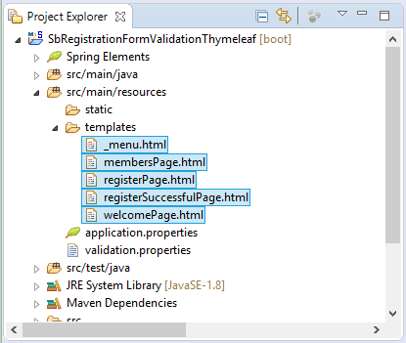

_menu.html

<**div** xmlns:th="http://www.thymeleaf.org"

style="border: 1px solid #ccc;padding:5px;margin-bottom:20px;">

<**a** th:href="@{/}">Home</**a**>

| &nbsp;

<**a** th:href="@{/members}">Members</**a**>

| &nbsp;

<**a** th:href="@{/register}">Register</**a**>

</**div**>

membersPage.html

<!DOCTYPE **HTML**>

<**html** xmlns:th="http://www.thymeleaf.org">

<**head**>

<**title** th:utext="${title}"></**title**>

</**head**>

<**style**>

**table** **th**, **table** **td** {

**padding**: 5px;

}

.message {

**color**: blue;

}

</**style**>

<**body**>

<!-- Include _menu.html -->

<**th:block** th:include="/_menu"></**th:block**>

<**h2**>Members</**h2**>

<**table** border="1">

<**tr**>

<**th**>User Name</**th**>

<**th**>First Name</**th**>

<**th**>Last Name</**th**>

<**th**>Email</**th**>

<**th**>Gender</**th**>

</**tr**>

<**tr** th:each ="member : ${members}">

<**td** th:utext="${member.userName}">...</**td**>

<**td** th:utext="${member.firstName}">...</**td**>

<**td** th:utext="${member.lastName}">...</**td**>

<**td** th:utext="${member.email}">...</**td**>

<**td** th:utext="${member.gender}">...</**td**>

</**tr**>

</**table**>

</**body**>

</**html**>

registerPage.html

<!DOCTYPE **HTML**>

<**html** xmlns:th="http://www.thymeleaf.org">

<**head**>

<**title** th:utext="${title}"></**title**>

<**style**>

**th**, **td** {

**padding**: 5px;

}

**td** **span** {

**font-size**:90%;

**font-style**: italic;

**color**: red;

}

.error {

**color**: red;

**font-style**: italic;

}

</**style**>

</**head**>

<**body**>

<!-- Include _menu.html -->

<**th:block** th:include="/_menu"></**th:block**>

<**h2**>Register</**h2**>

<**div** th:if="${errorMessage != null}"

th:utext="${errorMessage}" class="error">...</**div**>

<**form** th:action="@{/register}" th:object="${appUserForm}" method="POST">

<**table**>

<**tr**>

<**td**>User Name</**td**>

<**td**><**input** type="text" th:field="*{userName}" /></**td**>

<**td**>

<**span** th:if="${#fields.hasErrors('userName')}" th:errors="*{userName}">..</**span**>

</**td**>

</**tr**>

<**tr**>

<**td**>Password</**td**>

<**td**><**input** type="password" th:field="*{password}" /> </**td**>

<**td**>

<**span** th:if="${#fields.hasErrors('password')}" th:errors="*{password}">..</**span**>

</**td**>

</**tr**>

<**tr**>

<**td**>Confirm</**td**>

<**td**><**input** type="password" th:field="*{confirmPassword}" /> </**td**>

<**td**>

<**span** th:if="${#fields.hasErrors('confirmPassword')}" th:errors="*{confirmPassword}">..</**span**>

</**td**>

</**tr**>

<**tr**>

<**td**>Email</**td**>

<**td**><**input** type="text" th:field="*{email}" /> </**td**>

<**td**>

<**span** th:if="${#fields.hasErrors('email')}" th:errors="*{email}">..</**span**>

</**td**>

</**tr**>

<**tr**>

<**td**>First Name</**td**>

<**td**><**input** type="text" th:field="*{firstName}" /> </**td**>

<**td**>

<**span** th:if="${#fields.hasErrors('firstName')}" th:errors="*{firstName}">..</**span**>

</**td**>

</**tr**>

<**tr**>

<**td**>Last Name</**td**>

<**td**><**input** type="text" th:field="*{lastName}" /> </**td**>

<**td**>

<**span** th:if="${#fields.hasErrors('lastName')}" th:errors="*{lastName}">..</**span**>

</**td**>

</**tr**>

<**tr**>

<**td**>Gender</**td**>

<**td**>

<**select** th:field="*{gender}">

<**option** value=""> -- </**option**>

<**option** value="M">Male</**option**>

<**option** value="F">Female</**option**>

</**select**>

</**td**>

<**td**>

<**span** th:if="${#fields.hasErrors('gender')}" th:errors="*{gender}">..</**span**>

</**td**>

</**tr**>

<**tr**>

<**td**>Country</**td**>

<**td**>

<**select** th:field="*{countryCode}">

<**option** value=""> -- </**option**>

<**option** th:each="country : ${countries}"

th:value="${country.countryCode}"

th:utext="${country.countryName}"/>

</**select**>

<**td**><**span** th:if="${#fields.hasErrors('countryCode')}" th:errors="*{countryCode}">..</**span**></**td**>

</**tr**>

<**tr**>

<**td**>&nbsp;</**td**>

<**td**>

<**input** type="submit" value="Submit" />

<**a** th:href="@{/}">Cancel</**a**>

</**td**>

<**td**>&nbsp;</**td**>

</**tr**>

</**table**>

</**form**>

</**body**>

</**html**>

registerSuccessfulPage.html

<!DOCTYPE **HTML**>

<**html** xmlns:th="http://www.thymeleaf.org">

<**head**>

<**title**>Successfully registered</**title**>

<**style**>

**span** {**color**: blue;}

</**style**>

</**head**>

<**body**>

<!-- Include _menu.html -->

<**th:block** th:include="/_menu"></**th:block**>

<**h2**>You have successfully registered!</**h2**>

<**div** th:if="${flashUser != null}">

<**ul**>

<**li**>User Name: <**span** th:utext="${flashUser.userName}">..</**span**></**li**>

<**li**>Email: <**span** th:utext="${flashUser.email}">..</**span**></**li**>

</**ul**>

</**div**>

</**body**>

</**html**>

WelcomePage.html

<!DOCTYPE **HTML**>

<**html** xmlns:th="http://www.thymeleaf.org">

<**head**>

<**title** th:utext="${title}"></**title**>

</**head**>

<**body**>

<!-- Include _menu.html -->

<**th:block** th:include="/_menu"></**th:block**>

<**h2**>Home Page!</**h2**>

</**body**>

</**html**>

9- Запуск додатків

Нажати на праву кнопку миші на проект вибрати:

* Запустіть додаток As/Spring Boot

